**PROJECT REPORT TEMPLATE**

**INTRODUCTION**

**My project topic is social media post.First did empathy map and brainstorm before starting the project.After that i did canva website login and start the project.**

**PROBLEM DEFINITION AND DESIGN THINKING**

**2.1 Empathy map**

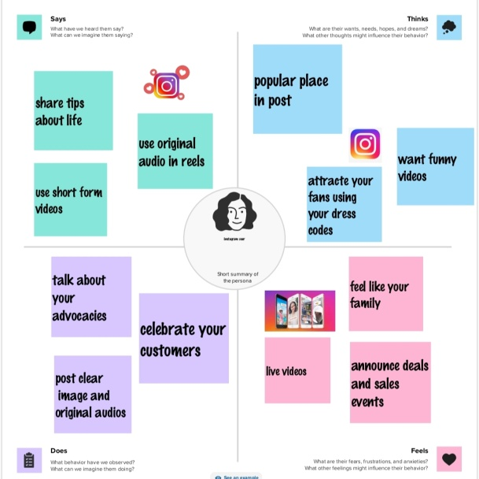

**2.2Ideation and brainstorming map**

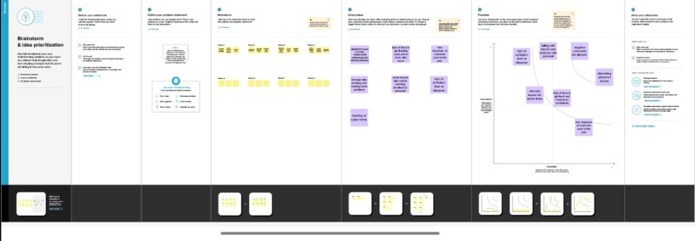

**RESULT**

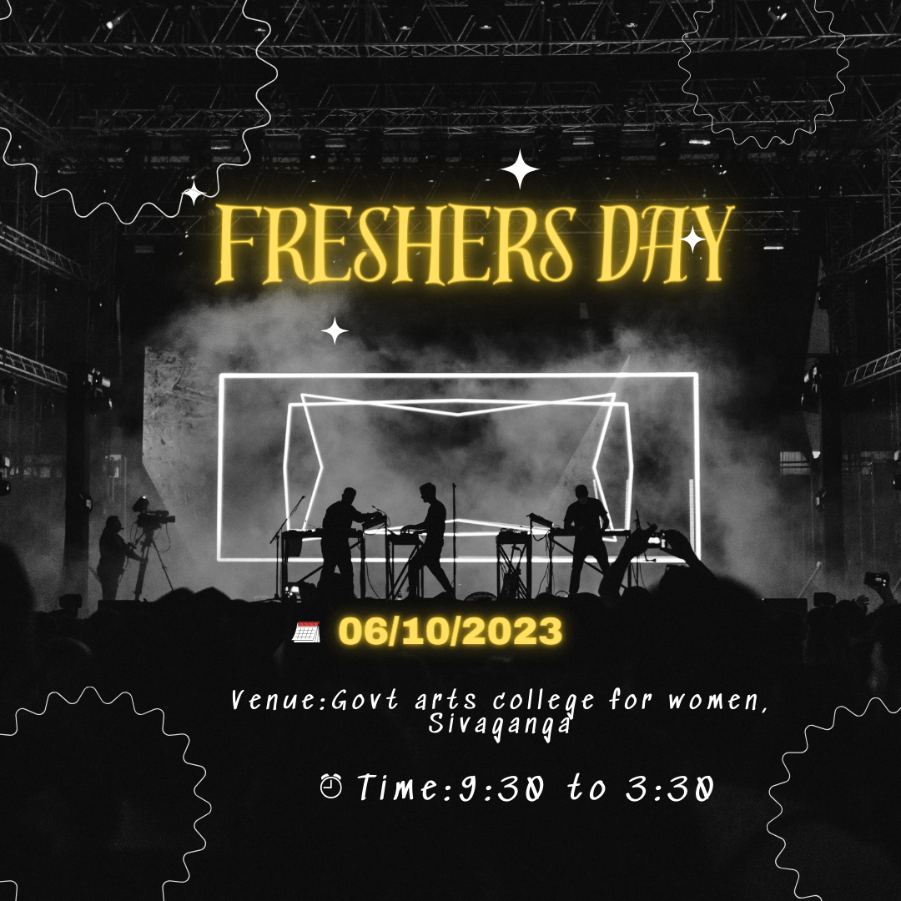

**ADVANTAGES AND DISADVANTAGES**

* **Advantages of canva with the canva website i learned how to design easily**
* **Disadvantages of canva i think it is difficult to uae the phone**

**APPLICATION**

**I use the laptop through canva websites**

**CONCLUSION**

**I learned how to use canva with laptop and then edited the design in my project**